Platform stat

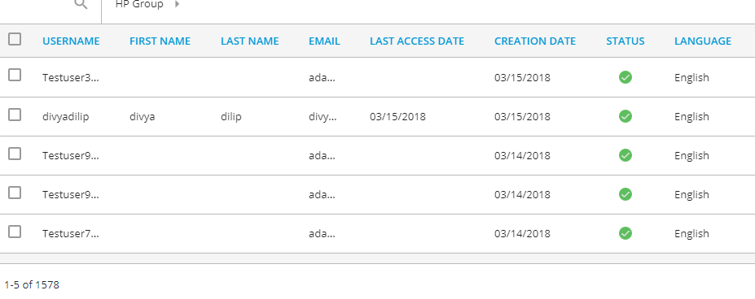

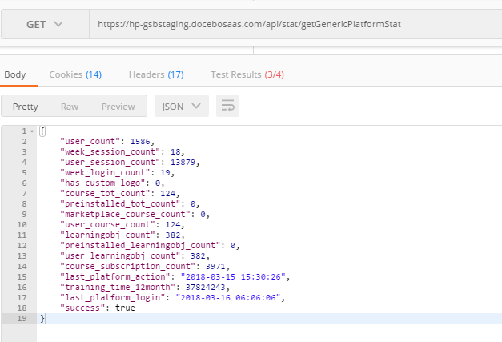

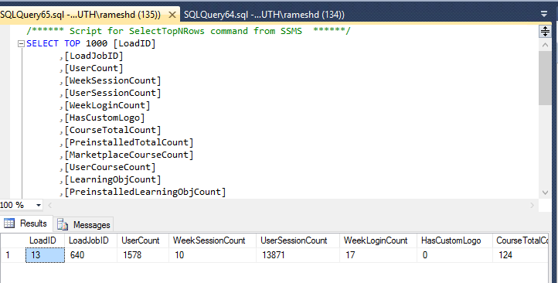

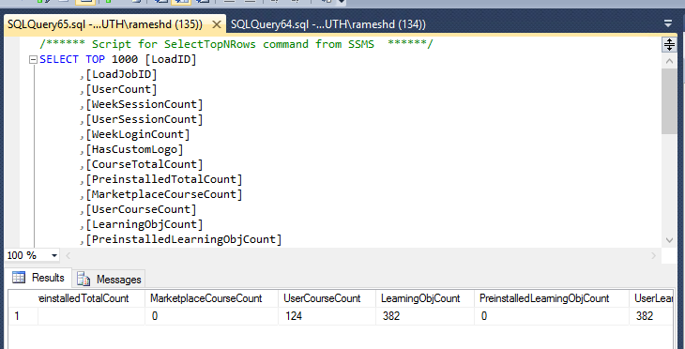

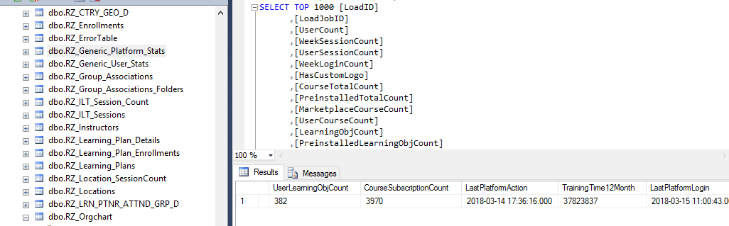

IC Table:

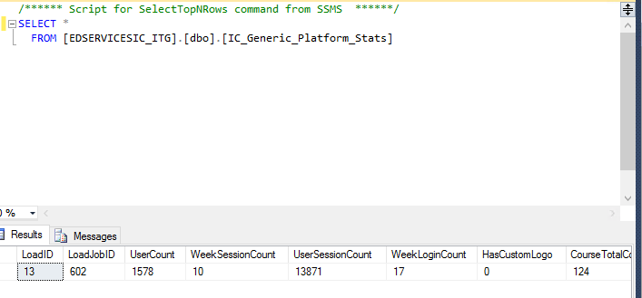

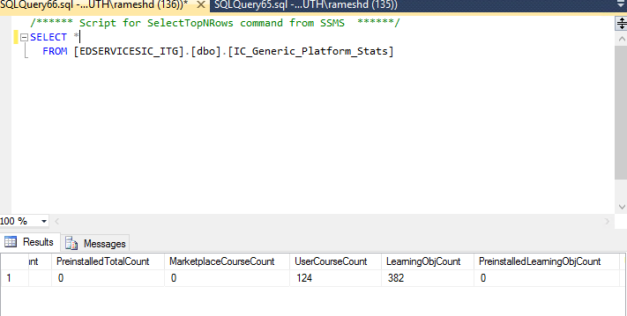

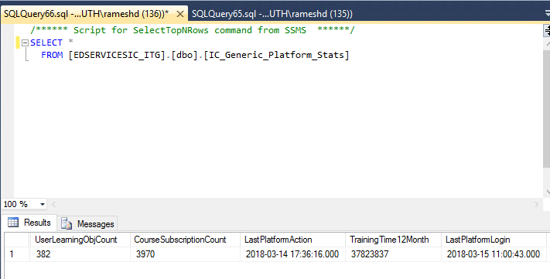

Deletion of user

"user_count": 1583,

"week_session_count": 18,

"user_session_count": 13879,

"week_login_count": 19,

"has_custom_logo": 0,

"course_tot_count": 123,

"preinstalled_tot_count": 0,

"marketplace_course_count": 0,

"user_course_count": 123,

"learningobj_count": 381,

"preinstalled_learningobj_count": 0,

"user_learningobj_count": 381,

"course_subscription_count": 3969,

"last_platform_action": "2018-03-15 15:30:26",

"training_time_12month": 37824243,

"last_platform_login": "2018-03-16 08:45:38",

"success": true

}

